Project Charter

Date: 05/15/2020

|  |  |  |  |
| --- | --- | --- | --- |
| **Project Title**: Board Game Development | | | |
| **Project Start Date:** 05/15/2020 **Projected Finish Date:** June 2020 | | | |
| **Budget Information:** Self-Funded | | | |
| **Project Manager:** Vineetha Yenugula, S538313@nwmissouri.edu | | | |
| **Project Objectives:** To develop a board game by providing user-friendly application and make its availability easy for everyone at anywhere without in need of physical board game. | | | |
| **Success Criteria:**Before the deadline we the expert team of game engineers will finish our board game application with a competence and skills which we need for the successful completion of our project with a bug free, user friendly design and it will be on live with Good Implementation. | | | |
| **Approach:**  **AGILE APPROACH** | | | |
| **Roles and Responsibilities** | | | |
| ***Name and Signature*** | ***Role*** | ***Position*** | ***Contact Information*** |
| 1. Bharath Kumar Gandhasiri | Team Lead | Team Lead | S538366@nwmissouri.edu |
| 1. Neelesh Saladi | Game Engineer/ Application Developer | Team Member | S538300@nwmissouri.edu |
| 1. Tejaswi Reddy Kandula | Game Engineer/ Application Developer | Team Member | S538309@nwmissouri.edu |
| 1. Vineetha Yenugula | Project Manager/Game Engineer | Project Manager | S538312@nwmissouri.edu |
| 1. Revanth Davuluri | Marketing Team | Team Member | S534917@nwmissouri.edu |
|  | | | |
| **Comments:** (Handwritten or typed comments from above stakeholders, if applicable) | | | |

**Signatures:**

Bharath Kumar Gandhasiri:

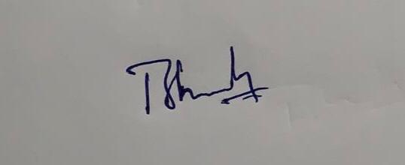

Neelesh Saladi:

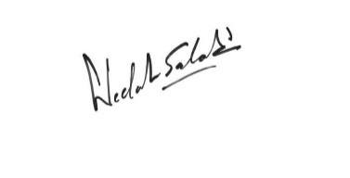

Tejaswi Reddy Kandula:

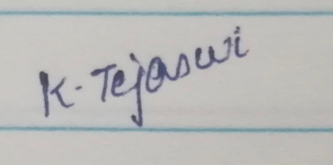

Vineetha Yenugula:

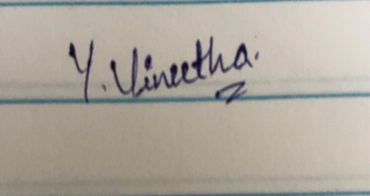

Revanth Davuluri:

